**DOCKER COMMANDS**

* docker –version
* docker ps

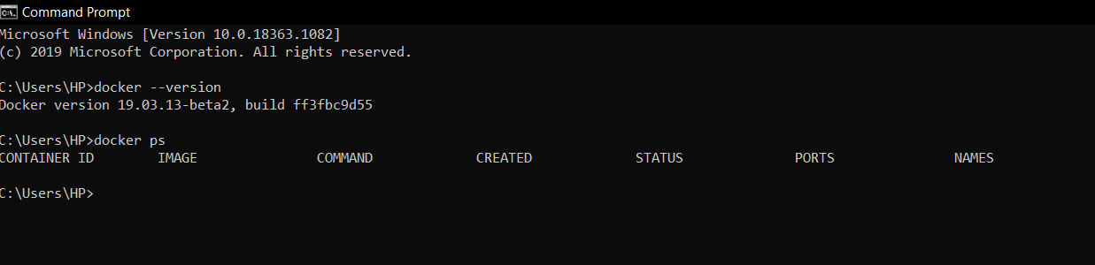

* docker build

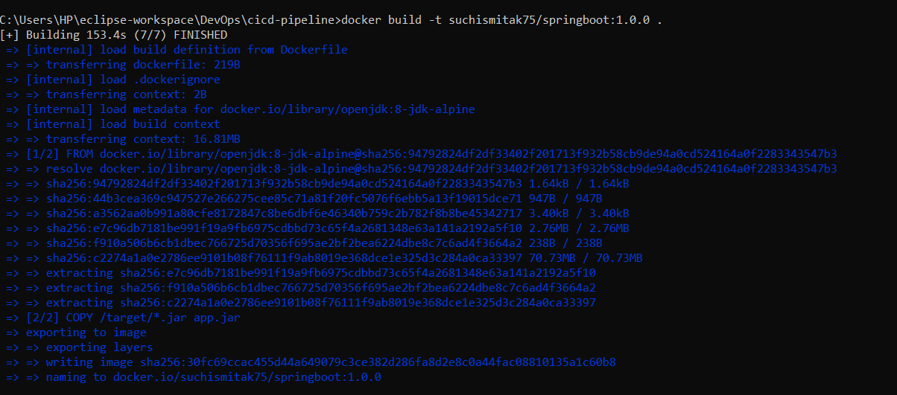

* docker push
* docker run
* From another machine (playground)
* docker pull
* docker run

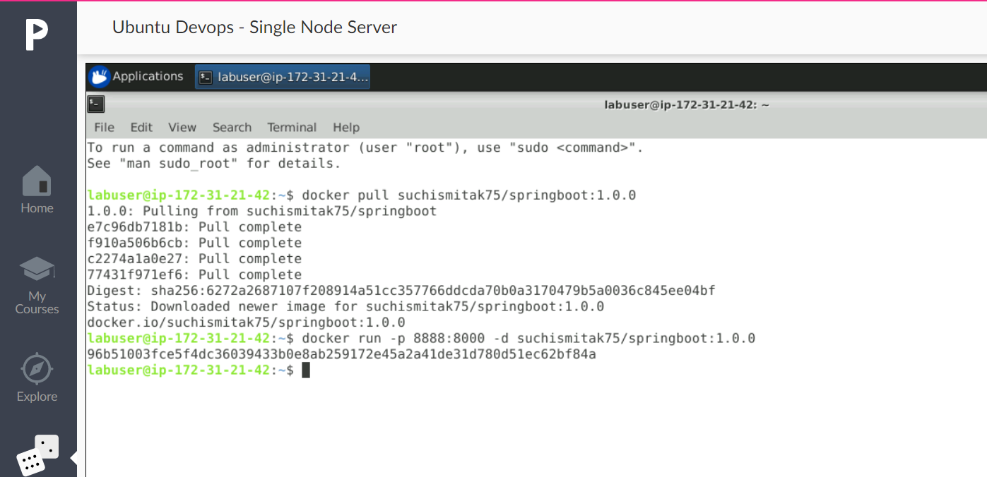

* **Docker hub repository :**

Suchismitak/springboot:1.0.0